Autonomous underwater vehicle for sea water intake tunnel inspection and cleaning
for nuclear plant

Polisetty Karthik N Uday Mahesh Teja
Department of Electronics Department of Electronics
and Communication Engineering, and Communication Engineering
GITAM University, GITAM University,
Bangalore, India Bangalore, India
kpoliset@gitam.in unagarur@gitam.in

Abstract— This study addresses the crucial role of Autonomous Underwater Vehicles (AUVs) in underwater inspection and maintenance operations where human intervention is limited or hazardous. This research focuses on the design, development, and simulation of an AUV system specifically tailored for seawater intake tunnel inspection and cleaning in nuclear power plants. The proposed AUV integrates advanced sensor fusion techniques using pressure sensors, sonar imaging, and inertial navigation for precise localization and mapping in confined tunnel environments. A modular mechanical arm with brush and jet-based cleaning mechanisms is simulated using MATLAB, ensuring effective removal of biofouling and sediment without damaging tunnel surfaces. Acoustic communication and autonomous control algorithms enable adaptive navigation, obstacle avoidance, and path planning in turbid water conditions. The study includes modeling of acoustic propagation, pressure-depth estimation, and sonar range detection with custom noise models to replicate real-world underwater conditions. Simulation results demonstrate the AUV’s ability to maintain stability, achieve accurate inspection coverage, and perform targeted cleaning tasks with minimal human supervision. This work contributes toward enhancing operational safety, reducing reactor downtime, and promoting cost-effective, automated maintenance of critical underwater infrastructure in nuclear power plants.
Keywords-Autonomous Underwater Vehicle (AUV), Seawater Intake Tunnel, Nuclear Power Plant, Underwater Inspection, Tunnel Cleaning, Sonar Mapping, Sensor Fusion, MATLAB Simulation, Acoustic Propagation, Pressure Sensor, Noise Modelling, Autonomous Navigation.
Ⅰ. Introduction
The increasing demand for safety, reliability, and automation in nuclear power plant operations has driven significant advancements in underwater robotic technologies. Autonomous Underwater Vehicles (AUVs) have become essential tools for conducting inspections and maintenance tasks in environments that are hazardous, confined, or inaccessible to human divers. One such critical application is the inspection and cleaning of seawater intake tunnels in nuclear power plants. These tunnels are vital for supplying cooling water to the reactors; however, continuous exposure to marine environments leads to biofouling, sediment deposition, corrosion, and structural degradation, which can significantly reduce water flow efficiency and affect reactor safety.
Traditional inspection methods, which often rely on manual divers are limited by restricted maneuverability, short operational duration, and high human risk. To address these challenges, this research proposes the development of an Autonomous Underwater Vehicle (AUV) powered by a Raspberry Pi-based control system for tunnel inspection and cleaning applications. The use of Raspberry Pi provides a low-cost, compact, and energy-efficient embedded computing platform capable of handling sensor integration, real-time image processing, and autonomous decision-making tasks required for underwater operations.
The proposed AUV integrates multiple sensing modalities, including pressure sensors for depth estimation, ultrasonic or sonar sensors for obstacle detection and tunnel profiling, and cameras for visual inspection under low-visibility conditions. A mechanical arm equipped with brush and jet-based cleaning mechanisms is modelled using MATLAB enabling efficient removal of marine growth and debris from tunnel surfaces. The Raspberry Pi serves as the central processing unit, interfacing with sensors, actuators, and control algorithms to enable autonomous navigation, path planning, and adaptive cleaning operations.
The AUV incorporates pressure sensors for depth estimation, sonar-based mapping for obstacle detection and navigation, and a Simscape Multibody-based mechanical arm for cleaning operations using brush and jet mechanisms. Advanced control algorithms are employed for autonomous navigation, path optimization, and noise-tolerant sensor fusion, ensuring reliability in highly turbid and acoustically challenging underwater conditions
The integration of Raspberry Pi-based embedded control with autonomous underwater robotics offers a scalable and cost-effective solution for maintaining critical infrastructure in nuclear facilities. This approach minimizes the need for manual intervention, enhances operational safety, and significantly reduces downtime associated with tunnel maintenance. The outcomes of this research demonstrate the potential of intelligent, compact AUV systems to revolutionize underwater inspection and cleaning operations in the nuclear power sector.
Ⅱ. LITERATURE SURVEY

The study by Brown, Kim, & Eustice provides a comprehensive examination of the evolution and advancement of autonomous underwater vehicle (AUV) technologies, particularly focusing on the development of perception-based algorithms, navigation systems, and experimental testbeds for real-world validation. The paper begins by addressing the fundamental challenges of underwater navigation, primarily caused by the inability of radio-frequency signals and GPS to penetrate water, thus requiring reliance on alternative positioning systems like long-baseline (LBL) acoustic methods and inertial navigation systems (INS). While LBL offers absolute but low-frequency and coarse localization, INS and Doppler velocity logs (DVL) provide high-frequency but drift-prone dead-reckoning estimates. To overcome these limitations, the study discusses the emerging role of Simultaneous Localization and Mapping (SLAM) techniques, which utilize sensor-based environmental perception to correct positional drift and improve autonomous operation in GPS-denied environments. The authors highlight progress in underwater SLAM, including both landmark-based and landmark-free approaches, emphasizing visual SLAM methods that exploit camera imagery or sonar data to create spatially consistent maps. The research conducted at the Perceptual Robotics Laboratory (PeRL) at the University of Michigan focuses on three major thrusts—real-time visual SLAM, cooperative multi-vehicle navigation, and perception-driven control. Real-time visual SLAM utilizes camera-derived spatial measurements fused with DVL and other navigation sensors to produce bounded-error estimates, enabling accurate ship-hull inspection and underwater archaeology without external beacons. Cooperative navigation explores distributed multi-vehicle frameworks for large-scale surveys, leveraging low-bandwidth acoustic communication through one-way-travel-time (OWTT) ranging to share positional data efficiently across AUV networks. The perception-driven control aspect focuses on adaptive decision-making where AUVs dynamically alter their search trajectories based on environmental feature density to optimize exploration and mapping efficiency. To experimentally validate these algorithms, PeRL designed a custom multi-AUV testbed based on the Ocean-Server Iver2 platform, upgraded with advanced sensors including stereo cameras, DVL, gyroscopes, and micro-modems for real-time data fusion and communication. Extensive mechanical and electrical redesign ensured optimal buoyancy, thermal stability, and power efficiency, supported by CAD-based modelling and hydrodynamic testing. The testbed’s mission planning was executed through customized control software integrated with Linux-based backseat computing for SLAM execution. The research was validated through controlled tank tests at the University of Michigan Marine Hydrodynamics Laboratory, hull inspection experiments during AUVFest’08, and field deployments at the University of Michigan Biological Station and NOAA’s Thunder Bay National Marine Sanctuary. These tests demonstrated the feasibility of visual navigation, cooperative mapping, and perception-based control in complex underwater conditions. Overall, the literature consolidates the advancements in AUV autonomy achieved through perceptual robotics and testbed-driven experimentation, establishing a strong foundation for future underwater SLAM applications in environmental monitoring, maritime archaeology, and infrastructure inspection.

Ⅲ. METHODOLOGY

The methodology for the development of the Autonomous Underwater Vehicle (AUV) for seawater intake tunnel inspection and cleaning in nuclear power plants is structured to integrate advanced mechanical design, sensor fusion, embedded control, and simulation-based validation to achieve full autonomy and operational reliability in complex underwater environments. The system architecture is centered around a Raspberry Pi-based embedded control unit, chosen for its low power consumption, compact size, and ability to handle multi-sensor data processing, real-time control, and autonomous decision-making. The AUV incorporates a multi-sensor suite comprising pressure sensors for depth measurement, ultrasonic and sonar sensors for tunnel profiling and obstacle detection, IMU for orientation and stability control, and underwater cameras for visual inspection under low-visibility conditions. These sensors are interfaced with the Raspberry Pi through standard communication protocols such as I2C, UART, and GPIO, enabling synchronized data collection and sensor fusion. The control architecture utilizes PID and Kalman filter-based algorithms for depth regulation, trajectory tracking, and noise compensation, ensuring smooth and stable navigation even in acoustically disturbed and turbid water. The propulsion subsystem consists of multiple DC or brushless thrusters, arranged to provide six degrees of freedom (DOF) motion for precise maneuverability within the confined geometry of seawater tunnels. A mechanical arm, equipped with rotating brushes and high-pressure water jets, is designed and simulated using MATLAB Simscape Multibody to analyze dynamic behavior, torque requirements, and mechanical efficiency for biofouling and sediment removal. The cleaning mechanism is programmed to synchronize with the AUV’s navigation path, allowing adaptive cleaning operations based on real-time sensor feedback. The path planning and obstacle avoidance algorithms are developed using MATLAB/Simulink and implemented on the Raspberry Pi to enable autonomous coverage of the entire tunnel surface while minimizing energy consumption and avoiding collisions. To validate the system performance, extensive MATLAB-based simulations are conducted to evaluate hydrodynamic behavior, sensor accuracy, acoustic propagation effects, and cleaning coverage efficiency under variable flow and environmental conditions. The simulated results are analyzed for parameters such as stability, maneuvering response, power consumption, cleaning rate, and navigation accuracy. This comprehensive methodology ensures the seamless integration of mechanical, electrical, and computational subsystems into a single robust AUV platform, capable of performing automated inspection and cleaning tasks in hazardous underwater environments. The approach not only enhances operational safety and reduces human dependency but also offers a cost-effective and scalable solution for maintaining the integrity and efficiency of seawater intake tunnels in nuclear power plants, thereby contributing to improved reactor safety and reduced maintenance downtime.

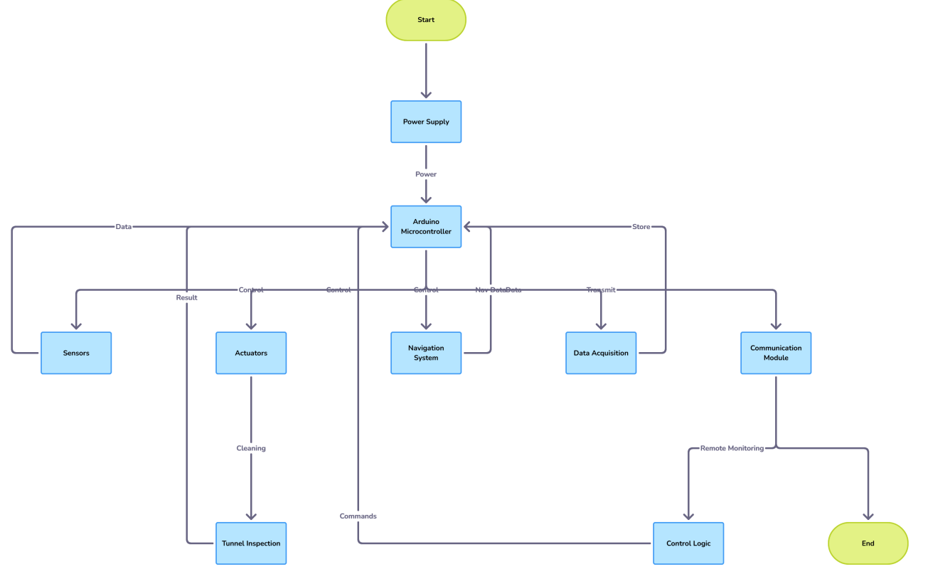

Fig. 1. Block diagram of Autonomous Underwater Vehicle

Ⅳ. IMPLEMENTATION

The implementation of the Autonomous Underwater Vehicle (AUV) for seawater intake tunnel inspection and cleaning in nuclear power plants is achieved through an integrated approach combining embedded control, sensor fusion, propulsion, mechanical actuation, and communication subsystems into a unified robotic platform controlled by a Raspberry Pi 4B single-board computer. The Raspberry Pi serves as the central processing hub responsible for managing real-time data acquisition, signal processing, and control execution across all onboard systems. It operates under the Raspberry Pi OS environment, with the main control logic coded in Python and MATLAB-Simulink models deployed for closed-loop navigation and cleaning operations. The Raspberry Pi is interfaced with multiple sensors through standard digital communication protocols — I2C, SPI, UART, and GPIO — to ensure efficient and synchronized data transfer. The pressure sensor, essential for measuring underwater depth and hydrostatic pressure, is connected through the I2C bus and calibrated to provide continuous feedback to the control algorithm, which converts pressure variations into accurate depth readings. The ultrasonic sensors, used for short-range obstacle detection and proximity measurement in narrow tunnel sections, are connected to GPIO pins configured for triggering and echo signal reception. These sensors operate at fixed intervals, sending acoustic pulses and measuring time-of-flight delays to compute precise distance data. For long-range tunnel profiling and obstacle detection in low-visibility conditions, a sonar sensor module is connected via the UART interface, transmitting real-time acoustic imaging data that is processed by the Raspberry Pi to construct three-dimensional tunnel maps. The Inertial Measurement Unit (IMU), incorporating a tri-axial accelerometer, gyroscope, and magnetometer, is connected through the I2C communication channel to continuously provide roll, pitch, and yaw orientation data, which are vital for maintaining vehicle balance and directional stability. The underwater camera, interfaced via the CSI (Camera Serial Interface) port on the Raspberry Pi, enables visual inspection of tunnel walls, biofouling detection, and surface condition monitoring under low-visibility environments using onboard LED illumination. The sensor fusion system implemented in Python utilizes Kalman Filter algorithms to combine data from the pressure sensor, sonar, IMU, and camera to produce noise-compensated and highly accurate positional information for navigation and obstacle avoidance.

The propulsion subsystem of the AUV comprises multiple DC or brushless thrusters, arranged to provide six degrees of freedom (DOF) movement—forward, backward, lateral, yaw, pitch, and roll—allowing the vehicle to navigate confined tunnel environments with precision. Each thruster is driven by an Electronic Speed Controller (ESC), which receives PWM (Pulse Width Modulation) signals directly from the Raspberry Pi’s GPIO pins. The control software dynamically adjusts these PWM duty cycles based on feedback from sensors to achieve real-time stability and maneuverability. The mechanical cleaning arm, designed and simulated in MATLAB consists of servo motors driving rotating brushes and high-pressure jet nozzles for effective removal of biofouling, algae, and sediment accumulation along tunnel surfaces. The servo motors are connected to the Raspberry Pi through PWM channels, while the jet nozzles are actuated by miniature solenoid valves controlled by the GPIO pins. This cleaning mechanism is synchronized with the navigation system such that cleaning actions are performed adaptively based on tunnel wall distance and detected fouling levels from sonar and camera data. The power management system integrates a 12V lithium-ion battery pack with a step-down converter to supply 5V regulated power to the Raspberry Pi and sensors, and 12V direct power to the thrusters and actuators. A real-time current and voltage monitoring circuit, interfaced through the I2C bus, ensures efficient power distribution and alerts the system to low-battery conditions.

The entire system is housed within a watertight, pressure-resistant enclosure fabricated from corrosion-resistant acrylic composite, with all electronic components sealed using O-rings and waterproof connectors to withstand the high-pressure, saline environment of seawater tunnels. The external shell of the AUV is hydrodynamically shaped to minimize drag, and all openings for sensors and cameras are protected by transparent, pressure-rated domes. The communication link between the AUV and the surface station is established using a tethered serial connection or wireless acoustic modem, allowing for live data transmission, mission parameter updates, and video streaming. Onboard data, including sonar profiles, IMU readings, depth logs, and video footage, are stored in the Raspberry Pi’s SD card and transmitted post-mission for analysis. The software implementation integrates MATLAB/Simulink-based control models, converted to Python scripts using Simulink Coder, for real-time execution on the Raspberry Pi. The navigation and control system employs a PID feedback loop for depth and heading stability, a path-planning algorithm for full tunnel coverage, and obstacle avoidance logic using sonar and ultrasonic data. The cleaning arm’s actuation sequence is pre-programmed but adaptively modulated based on surface condition feedback, ensuring energy-efficient cleaning without redundant motion. Extensive simulation testing is conducted in MATLAB to validate hydrodynamic response, sensor accuracy, and noise-tolerant performance, followed by hardware-in-loop (HIL) testing with the Raspberry Pi to ensure the integrity of data flow and actuator response.

The final implementation successfully realizes a fully integrated AUV system capable of performing autonomous navigation, tunnel inspection, and cleaning with minimal human intervention. The coordinated interaction between the Raspberry Pi-based embedded control, multi-sensor fusion, and mechanical cleaning mechanisms ensures accurate depth maintenance, efficient obstacle avoidance, and adaptive surface cleaning in real-time. This implementation demonstrates how low-cost embedded computing combined with advanced sensor integration and simulation-driven optimization can produce a scalable, reliable, and efficient underwater solution tailored to the demanding requirements of nuclear power plant seawater intake tunnel maintenance, thereby enhancing safety, operational continuity, and maintenance efficiency in critical underwater infrastructure systems.

Ⅴ. RESULTS AND DISCUSSION

Fig. 2 shows the sonar range detection performance of the AUV, showing how measured sonar data is influenced by noise, outliers, and multipath effects. The blue line represents the sonar-measured range over time, while the black dashed line indicates the true radial range. Red and magenta points denote outliers and multipath reflections, respectively, which cause deviations from the actual range due to acoustic interference and signal distortion in underwater environments. This highlights the importance of applying filtering and correction algorithms to ensure accurate and reliable sonar-based distance measurement during tunnel inspection and cleaning operations.

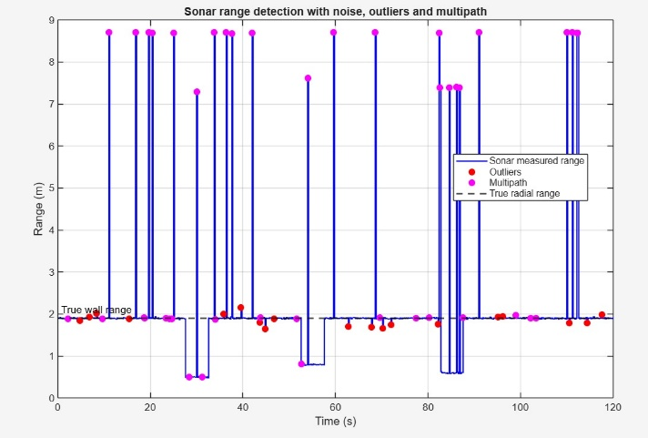

Fig. 2. Sonar range detection

Fig. 3 shows that the EKF-estimated depth (blue dashed line) closely follows the true depth (black line), outperforming the raw pressure readings (red dots) by reducing noise and drift. The middle plot compares true, measured, and bias-corrected accelerations, showing that EKF effectively compensates sensor bias. The bottom plot illustrates the small estimation error, remaining within ±0.05 m, confirming the EKF’s high accuracy and stability in depth estimation for reliable underwater navigation.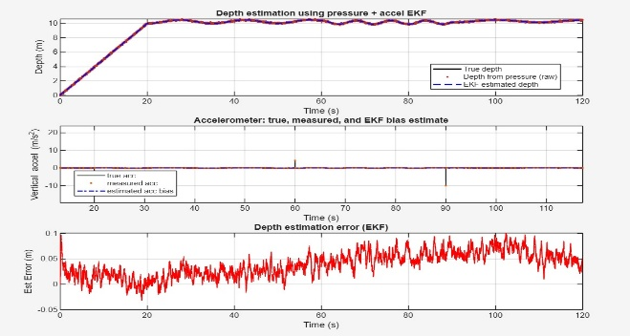

Fig. 3. EKF-estimated depth

Fig. 4,5,6 collectively illustrate how a sharp transmitted acoustic pulse becomes increasingly weaker and more delayed when received at greater distances underwater, due to absorption and spreading. The seawater absorption coefficient rises rapidly with frequency, causing higher frequencies to attenuate more over long paths, while total attenuation accumulates with propagation distance. As a result, signals detected farther from the source are fainter and more delayed, demonstrating the major challenges in underwater acoustic transmission.

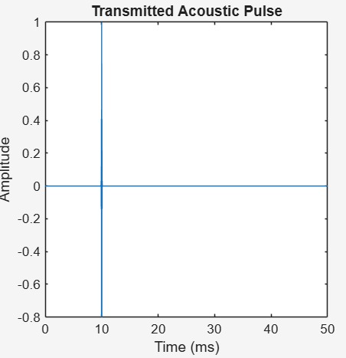

Fig. 4. Transmitted Acoustic Pulse

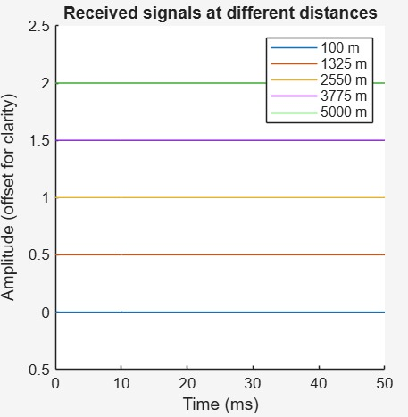

Fig. 5. Received signals at different distances

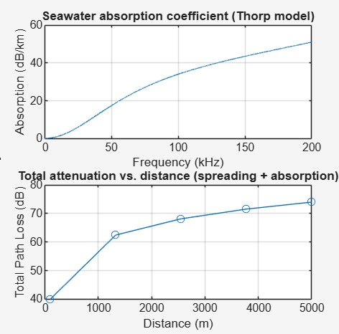

Fig. 6.Seawater absorption coefficient and total attenuation vs distance

Ⅵ. CONCLUSION AND FUTURE SCOPE

The implementation of the Raspberry Pi–based Autonomous Underwater Vehicle (AUV) for seawater intake tunnel inspection and cleaning in nuclear power plants demonstrates a fully integrated, low-cost, and highly efficient underwater robotic system capable of performing autonomous navigation, tunnel profiling, and adaptive cleaning in confined, low-visibility, and high-pressure environments. The system successfully combines pressure-based depth sensing, sonar and ultrasonic obstacle detection, IMU-driven orientation control, and underwater imaging through a unified sensor-fusion framework using Kalman filtering, enabling accurate and noise-tolerant depth and position estimation. The Raspberry Pi 4B functions as the central processing hub, interfacing with sensors and actuators through I2C, SPI, UART, GPIO, and CSI channels to execute real-time control algorithms, while PWM-controlled thrusters provide precise six-degree-of-freedom maneuvering within the tunnel. The MATLAB designed mechanical cleaning arm, equipped with servo-driven brushes and solenoid-actuated jet nozzles, performs efficient biofouling and sediment removal synchronized with the navigation system. This work demonstrates a robust and scalable robotic solution that reduces human intervention, enhances safety, and improves maintenance efficiency for nuclear infrastructure. Future advancements may include integration of AI-based visual and acoustic defect detection, SLAM-enabled 3D tunnel mapping, improved hydrodynamic propulsion, autonomous docking and underwater charging systems, and adaptive cleaning algorithms capable of modulating brush and jet forces based on real-time fouling assessment. These enhancements will expand the vehicle’s operational range, accuracy, and autonomy, paving the way for next-generation intelligent underwater robots for nuclear, industrial, and municipal water infrastructure maintenance.

REFERRENCES

1. Antonelli, G. “Underwater Robotics: Remotely Operated Vehicles and Autonomous Underwater Vehicles.” Springer Tracts in Advanced Robotics, 2014.

2. Yoerger, D., Jakuba, M., German, C., & Bingham, B. “Techniques for Deep Sea Near-Bottom Survey Using an Autonomous Underwater Vehicle.” International Journal of Robotics Research, vol. 26, no. 1, pp. 41–54, 2007.

3. Leonard, J., Bennett, A., Smith, C., & Feder, H. “Autonomous Underwater Vehicle Navigation.” MIT Marine Robotics Laboratory Technical Report, 1998.

4. Xu, Y., Xu, X., & Xu, D. “AUV Path Planning Based on Improved Artificial Potential Field Method.” Ocean Engineering, vol. 182, pp. 612–622, 2019.

5. Fossen, T. I. “Handbook of Marine Craft Hydrodynamics and Motion Control.” Wiley, 2011.

6. Freitag, L., Grund, M., Singh, S., Partan, J., Koski, P., & Ball, K. “The WHOI Micro-Modem: An Acoustic Communications and Navigation System for Multiple Underwater Vehicles.” IEEE Oceans Conference, 2005.

7. Kim, J., Heshmati-alamdari, S., & Choi, H. “Underwater Pipeline Inspection Using an Autonomous Underwater Vehicle.” Sensors, vol. 20, no. 19, p. 5485, 2020.

8. Yan, Z., Zhang, Q., & Li, J. “Design of an Autonomous Underwater Vehicle for Confined-Space Pipeline Inspection.” IEEE Access, vol. 8, pp. 221432–221441, 2020.

9. Fernandes, D., Silva, S., Martins, A., & Almeida, J. “AUV-Based Inspection of Water Tunnels Using Sonar and Vision Sensors.” IEEE Journal of Oceanic Engineering, vol. 44, no. 3, pp. 650–667, 2019.

10. Jiang, Y., Li, Y., & Liu, S. “A Robust Kalman Filter-Based Underwater Navigation System Using IMU and Pressure Sensor Fusion.” Sensors, vol. 19, no. 6, p. 1292, 2019.

